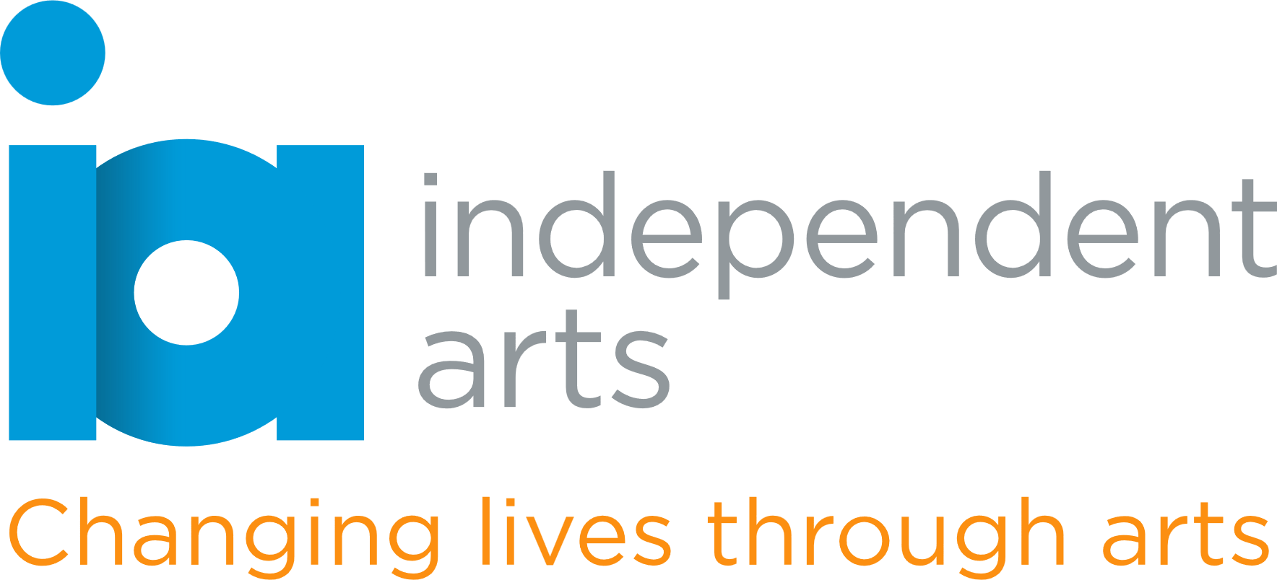

**Trustee Role Description – Healthcare / Social Prescribing**

**Organisation:** Independent Arts  
**Location:** Isle of Wight  
**Time Commitment:** Approximately 4 board meetings per year plus occasional support between meetings  
**Reporting to:** Chair of Trustees

**About Independent Arts**

Independent Arts is a creative well-being charity using the arts to improve wellbeing, reduce isolation, and promote social inclusion across the Isle of Wight. Through workshops, community engagement, and creative programmes, we support people of all ages and backgrounds—especially those who are vulnerable or marginalised.

We are seeking a new trustee with experience in **healthcare, social prescribing, or community wellbeing** to support the development of our services and ensure alignment with wider health and care strategies.

**Key Responsibilities**

* Fulfil statutory duties as a trustee, ensuring the charity is well-governed and compliant with Charity Commission guidance.
* Provide strategic insight into healthcare systems, social prescribing initiatives, and community wellbeing policies.
* Help the charity align its services with local health priorities and build strong partnerships within the NHS and voluntary sectors.
* Support the development and evaluation of arts-based health interventions, particularly those aimed at improving mental health and reducing social isolation.
* Act as a critical friend to staff, sharing sector insight and fostering collaboration with healthcare professionals and networks.

**Skills and Experience Sought**

* Experience in healthcare, public health, social work, mental health services, or social prescribing pathways.
* Understanding of NHS structures, Integrated Care Systems (ICSs), or the voluntary/community sector's role in health delivery.
* Strategic thinking and ability to contribute to board-level decision-making.
* A commitment to person-centred care and reducing health inequalities through creative means.
* Excellent communication and collaboration skills.

**Time Commitment and Term**

* The Board typically meets quarterly, with meetings lasting around 2 hours.
* Trustees are also expected to contribute between meetings and may sit on sub-committees.
* Trustees are usually appointed for a term of 3 years, renewable twice.

**What You’ll Gain**

* The opportunity to make a meaningful impact on a small charity with a big local footprint.
* Collaborative work with a passionate and supportive board.
* The chance to apply your skills and experience to a social cause.

**Application**

Prior board or trustee experience is welcome but not essential. We are committed to diversity and welcome applicants from all backgrounds. If you do not meet the criteria specified but have a passion for our work, we would still like to hear from you.

**To apply or find out more**, please visit our website [independentarts.org.uk](http://www.independentarts.org.uk) and/or

email Jacquie Heany, Chair of Trustees [trustees@independentarts.org.uk](mailto:trustees@independentarts.org.uk)