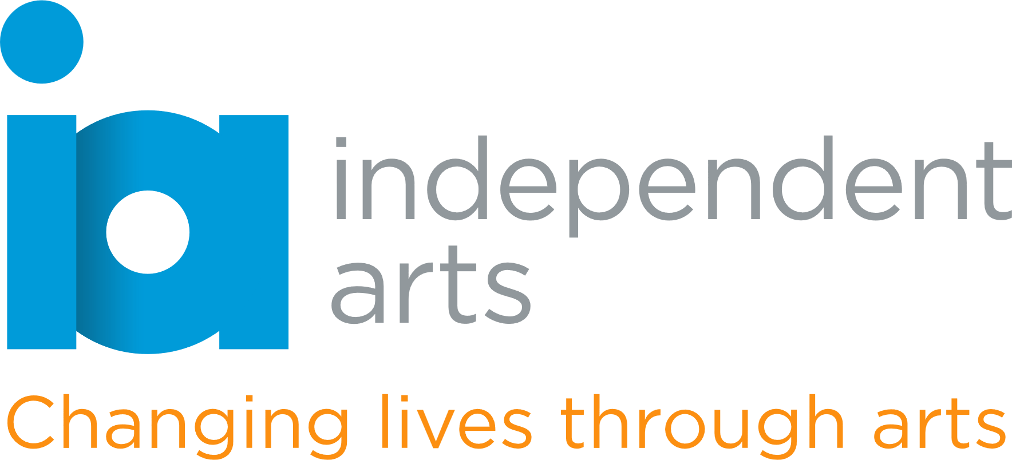

**Trustee Role Description – Information Security Specialist**

**Organisation:** Independent Arts  
**Location:** Newport, Isle of Wight  
**Commitment:** 4 board meetings per year + additional advisory support as needed  
**Reporting to:** Chair of Trustees

**About Independent Arts**

Independent Arts is a creative well-being charity using the arts to improve wellbeing, reduce isolation, and promote social inclusion across the Isle of Wight. Through workshops, community engagement, and creative programmes, we support people of all ages and backgrounds—especially those who are vulnerable or marginalised.

We are seeking a new trustee with professional experience in **information security and data protection** to join our Board and help guide our digital strategy and safeguard sensitive information.

**Key Responsibilities**

* Fulfil the statutory duties of a charity trustee as set out by the Charity Commission.
* Provide strategic oversight and expert advice on matters relating to information security, data protection (including GDPR compliance), and digital risk.
* Support the charity in developing and maintaining robust policies on cyber security, digital safeguarding, and secure data handling.
* Advise on the selection and use of digital tools and platforms to ensure they meet appropriate security standards.
* Work with the board and staff team to enhance awareness and training on information security issues.

Contribute to overall strategic planning and governance in line with the charity’s aims.

**Skills and Experience Sought**

* Proven expertise in information security, cyber risk management, or IT governance.
* Familiarity with UK data protection regulations and compliance standards (e.g. GDPR, ISO 27001).
* Experience advising or working with non-profits or SMEs is an advantage.
* Strong communication skills and the ability to explain complex issues in plain language.

Commitment to the values and mission of Independent Arts.

**Time Commitment and Term**

* The Board typically meets quarterly, with meetings lasting around 2 hours.
* Trustees are also expected to contribute between meetings and may sit on sub-committees.

Trustees are usually appointed for a term of 3 years, renewable twice.

**What You’ll Gain**

* The opportunity to make a meaningful impact on a small charity with a big local footprint.
* Collaborative work with a passionate and supportive board.
* The chance to apply your professional skills to a social cause.

**Application**

Prior board or trustee experience is welcome but not essential. We are committed to diversity and welcome applicants from all backgrounds. If you do not meet the criteria specified but have a passion for our work, we would still like to hear from you.

**To apply or find out more**, please visit our website [independentarts.org.uk](http://www.independentarts.org.uk) and/or

email Jacquie Heany, Chair of Trustees [trustees@independentarts.org.uk](mailto:trustees@independentarts.org.uk)