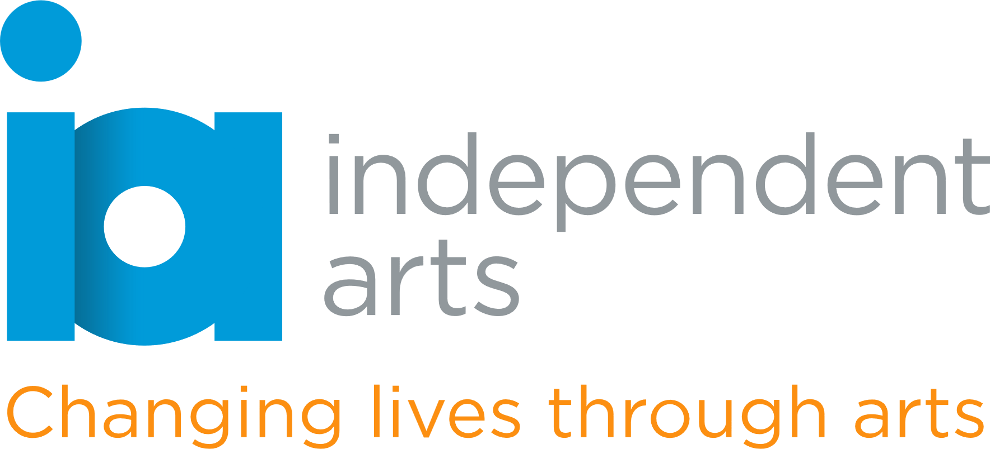

**Young Trustee Role Description (Aged 18–25)**

**Organisation:** Independent Arts  
**Location:** Isle of Wight   
**Time Commitment:** 4 board meetings per year + optional involvement in projects  
**Type of Role:** Voluntary   
**Reporting to:** Chair of Trustees

**About Independent Arts**

Independent Arts is a creative well-being charity using the arts to improve wellbeing, reduce isolation, and promote social inclusion across the Isle of Wight. Through workshops, community engagement, and creative programmes, we support people of all ages and backgrounds—especially those who are vulnerable or marginalised.

We believe that our board should reflect the communities we serve. That’s why we’re looking for a **Young Trustee aged 18–25** to bring a fresh perspective to our decision-making, help shape our future and ensure that the voices of younger people are represented at the highest level of the organisation.

**What You'll Do as a Trustee**

* Attend board meetings and help make decisions about the direction and priorities of the charity
* Share your views on how Independent Arts can connect with and support younger people
* Contribute to discussions on campaigns, programmes, or projects you care about
* Learn how a charity works and gain real leadership experience
* Act as an ambassador for the charity in your community or network

**Who We're Looking For**

You don’t need to have been a trustee before or have lots of formal experience. We’re looking for someone who:

* Is aged between 18 and 25
* Cares about creativity, wellbeing, and community
* Can offer ideas, insight, or lived experience that helps shape our work
* Is willing to learn, ask questions, and take part in discussions
* May have been involved in youth work, social action, the arts, or voluntary/community organisations (but this is not essential)

We welcome applications from people from all backgrounds and lived experiences—especially those who may not have seen themselves on a board before.

**What You’ll Gain**

* A chance to help lead a local charity and influence real change
* Build your confidence and leadership skills
* Learn about governance, strategy, and how charities work
* Work alongside experienced professionals who will support and mentor you
* Great experience for your CV or future career in the charity or public sector

**Term and Time Commitment**

* Term: 1–3 years (flexible)
* Board meetings: Around 4 per year, held online or on the Isle of Wight
* Optional involvement in sub-groups, events, or special projects

**Application**

**To apply or find out more**, please visit our website [independentarts.org.uk](http://www.independentarts.org.uk) and/or

email Jacquie Heany, Chair of Trustees [trustees@independentarts.org.uk](mailto:trustees@independentarts.org.uk)